ASSIGNMENT 1

**DOMAIN**: IOT

ASSIGNMENT ON SMART HOME AUTOMATION IN TINKERCAD

**TEAM MEMBERS:**

* + - * DHOSHINIE S - 513119106016
      * JAPAKUMAR M - 513119106031
      * JAYAKUMAR B – 513119106032
      * GAUTAM VINAY S - 513119106302

**COMPONENTS REQUIRED**

|  |  |  |
| --- | --- | --- |
| **NAME** | **QUANTITY** | **COMPONENT** |
| **U1** | **1** | **Arduino Uno R3** |
| **PIR1** | **1** | **-25.91243809621563, -172.15960267497042, -218.52671187202583 PIR Sensor** |
| **PING 1** | **1** | **Ultrasonic Distance Sensor** |
| **SERVO1** | **1** | **Positional Micro Servo** |
| **D1** | **1** | **Blue LED** |
| **R1** | **1** | **1 kiloohm Resistor** |

**WORK IN TINKERCAD**

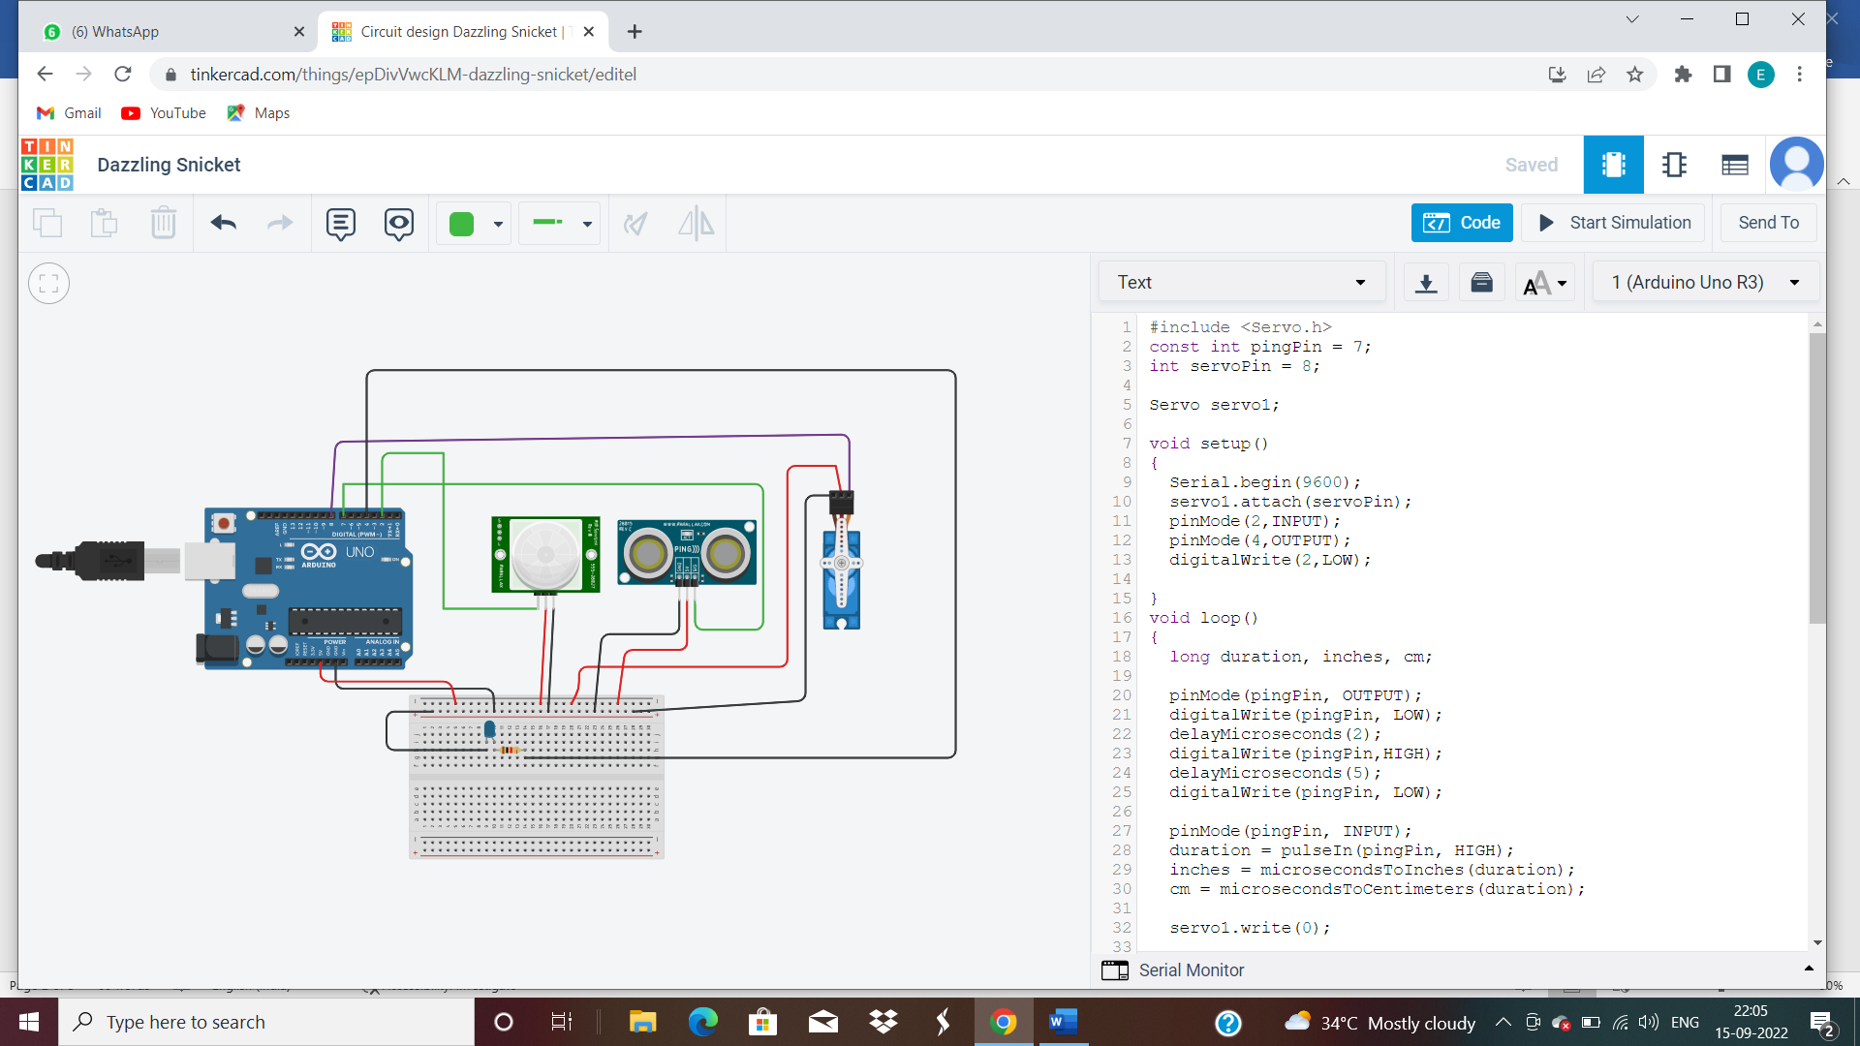

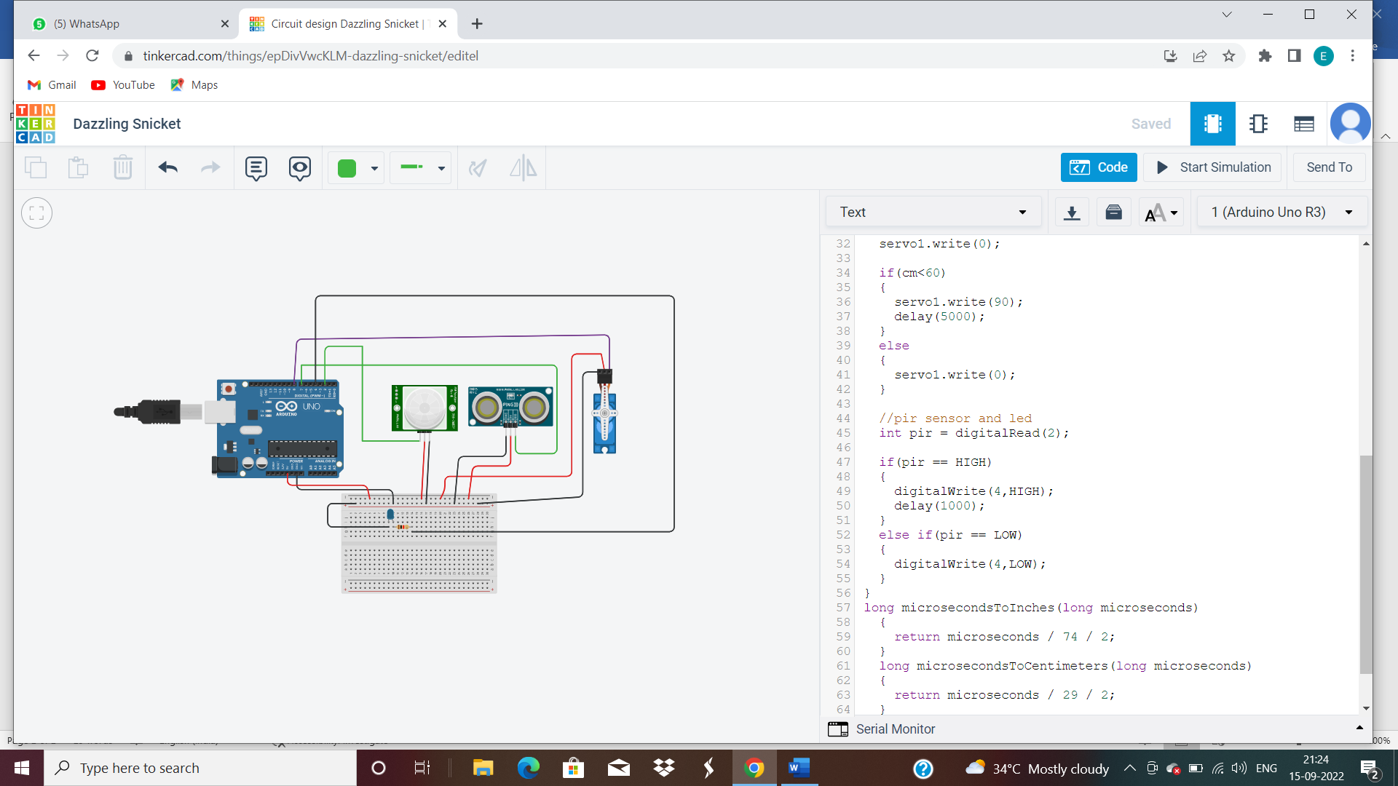

**CIRCUIT**

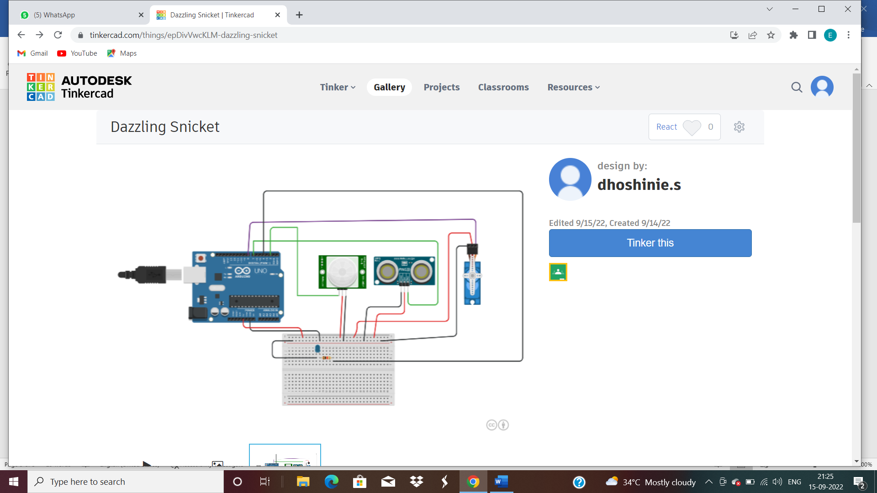

**CODING**

#include <Servo.h>

const int pingPin = 7;

int servoPin = 8;

Servo servo1;

void setup()

{

Serial.begin(9600);

servo1.attach(servoPin);

pinMode(2,INPUT);

pinMode(4,OUTPUT);

digitalWrite(2,LOW);

}

void loop()

{

long duration, inches, cm;

pinMode(pingPin, OUTPUT);

digitalWrite(pingPin, LOW);

delayMicroseconds(2);

digitalWrite(pingPin,HIGH);

delayMicroseconds(5);

digitalWrite(pingPin, LOW);

pinMode(pingPin, INPUT);

duration = pulseIn(pingPin, HIGH);

inches = microsecondsToInches(duration);

cm = microsecondsToCentimeters(duration);

servo1.write(0);

if(cm<60)

{

servo1.write(90);

delay(5000);

}

else

{

servo1.write(0);

}

//pir sensor and led

int pir = digitalRead(2);

if(pir == HIGH)

{

digitalWrite(4,HIGH);

delay(1000);

}

else if(pir == LOW)

{

digitalWrite(4,LOW);

}

}

long microsecondsToInches(long microseconds)

{

return microseconds / 74 / 2;

}

long microsecondsToCentimeters(long microseconds)

{

return microseconds / 29 / 2;

}

**TINKERCAD LINK**

<https://www.tinkercad.com/things/epDivVwcKLM-dazzling-snicket/editel>